Basic Shell Scripts:

Output to screen

#!/bin/bash
# Simple output script

echo "Hello Techno World"

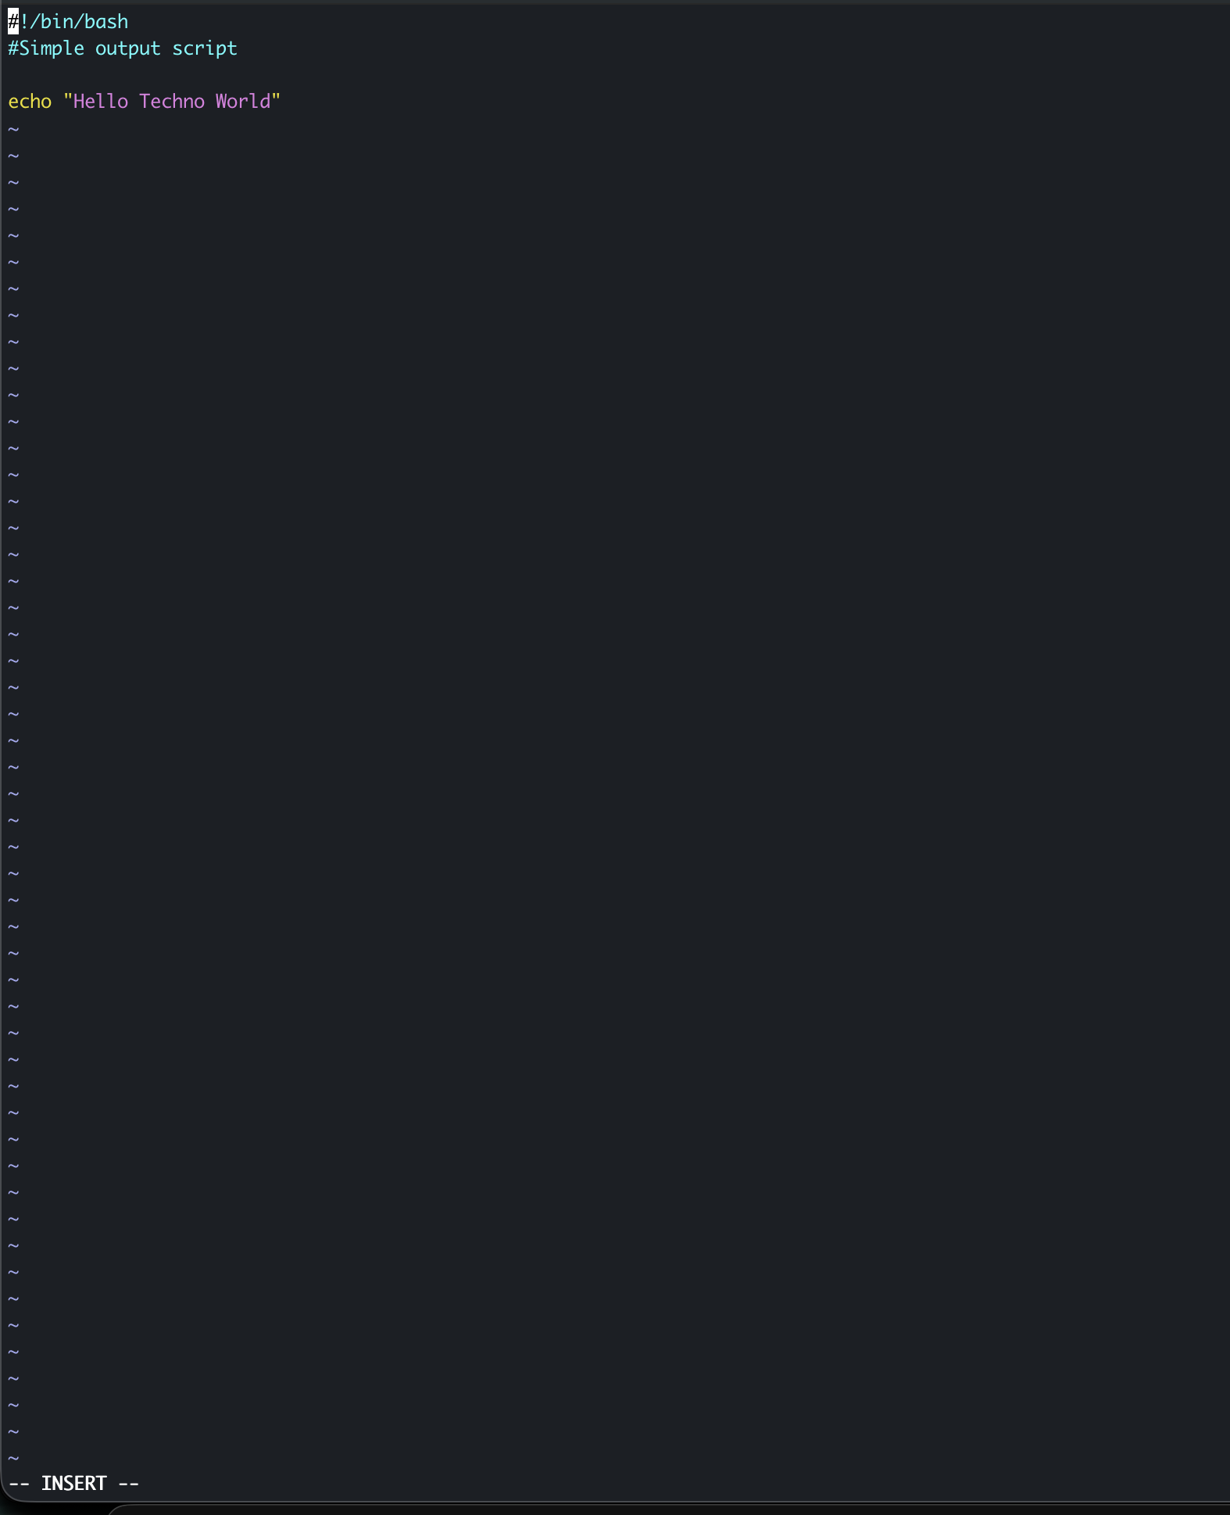

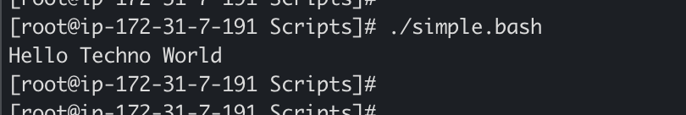

Defining Tasks

#!/bin/bash
#Dining Small task

echo "WhoAmI"
whoami
echo "Running processes"
ps -ef
echo "Present Working Directory"
pwd
echo "List files"
ls -ltr
echo

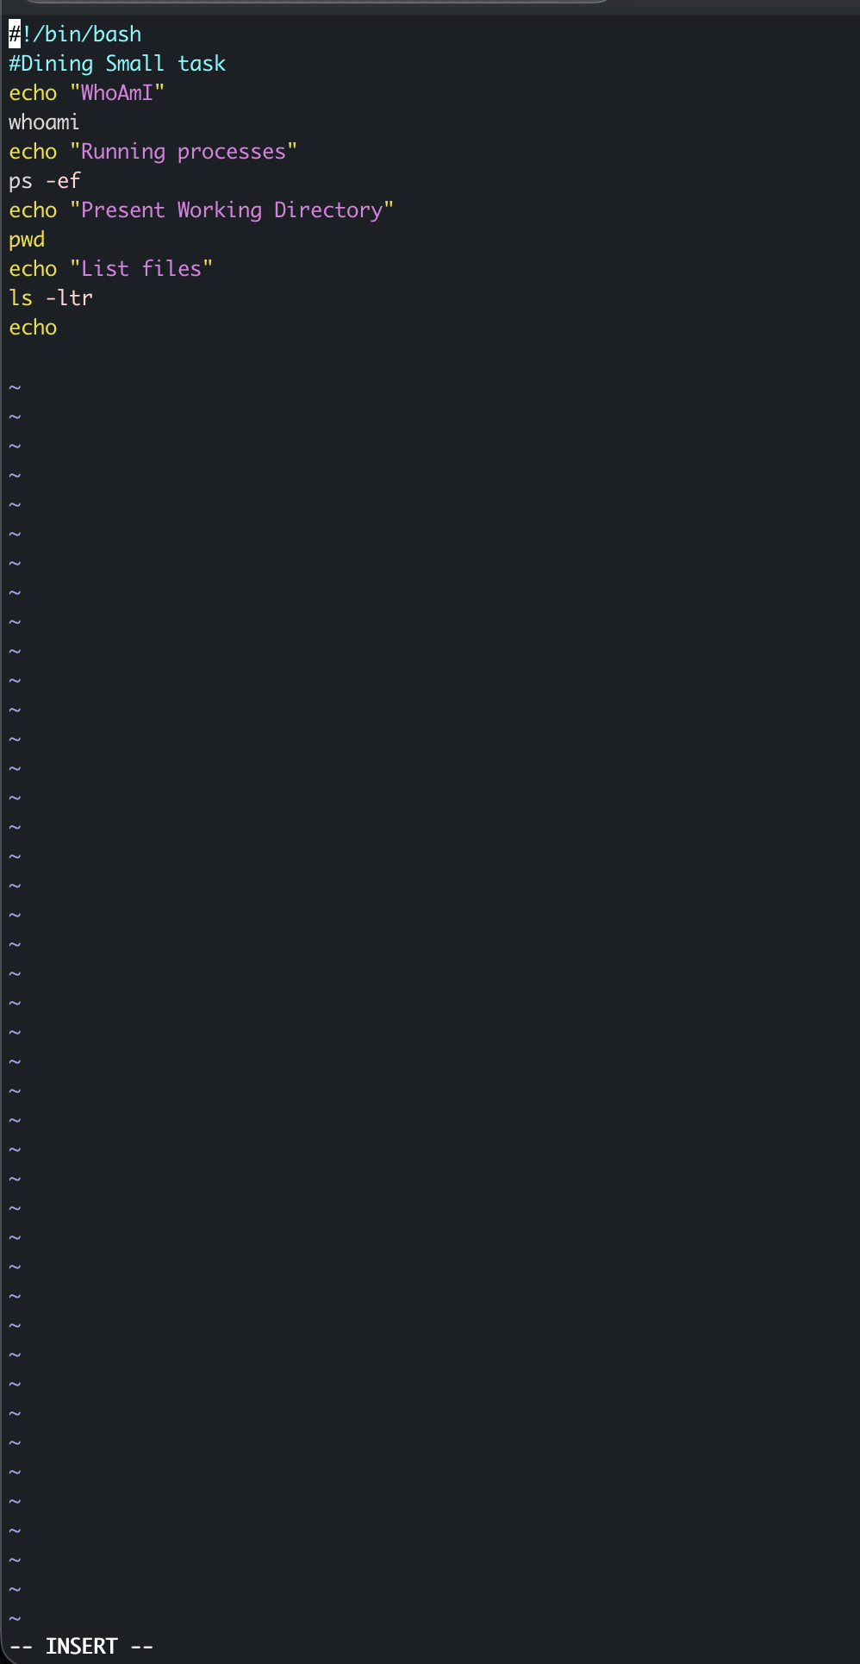
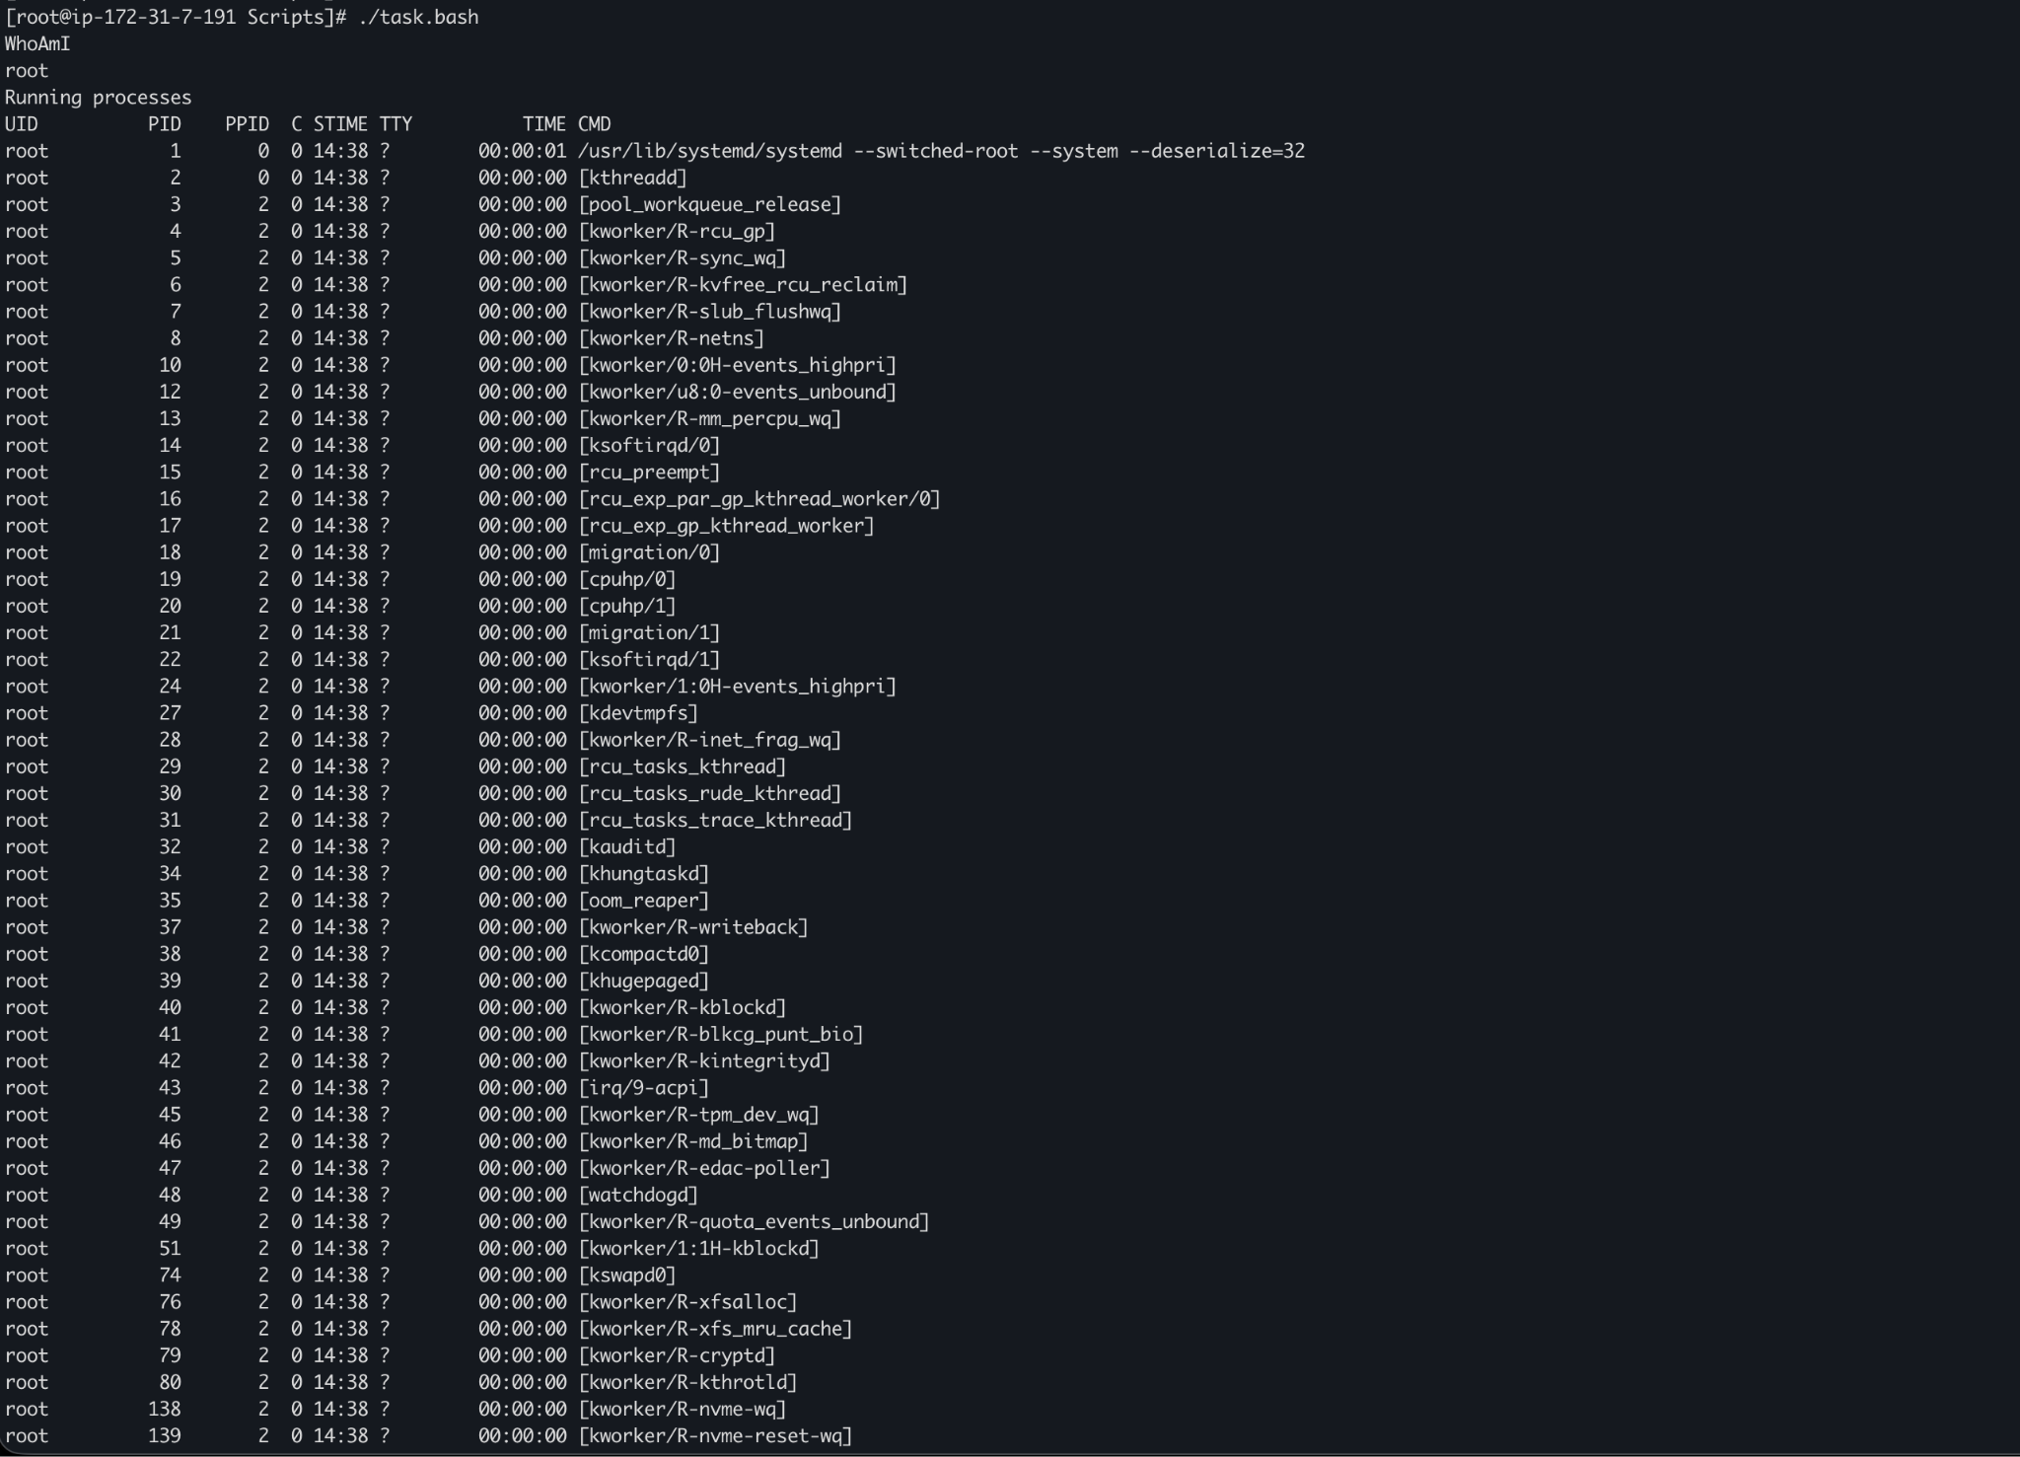
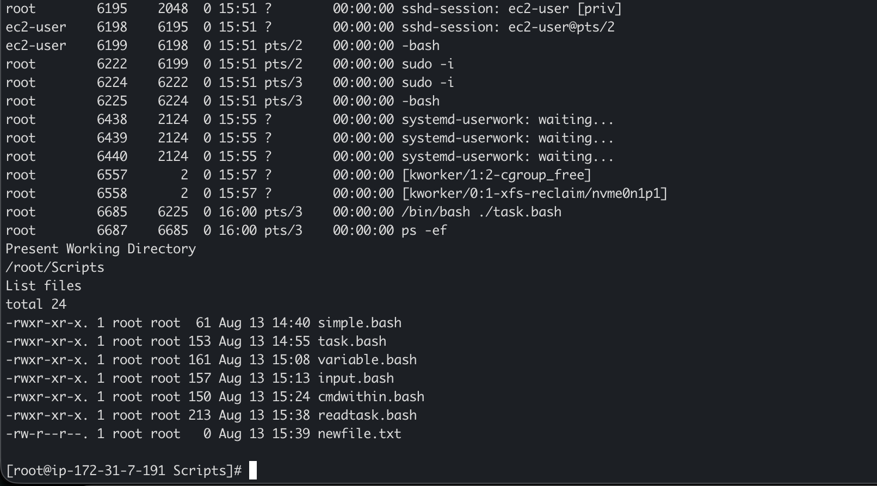

Defining variables

#!/bin/bash
# Defining variables

a=Mohammed
b="Abdul Nayeem"
c="Techie Horizon"

echo "My first name is : $a"
echo "My last name is : $b"
echo "I joined : $c"

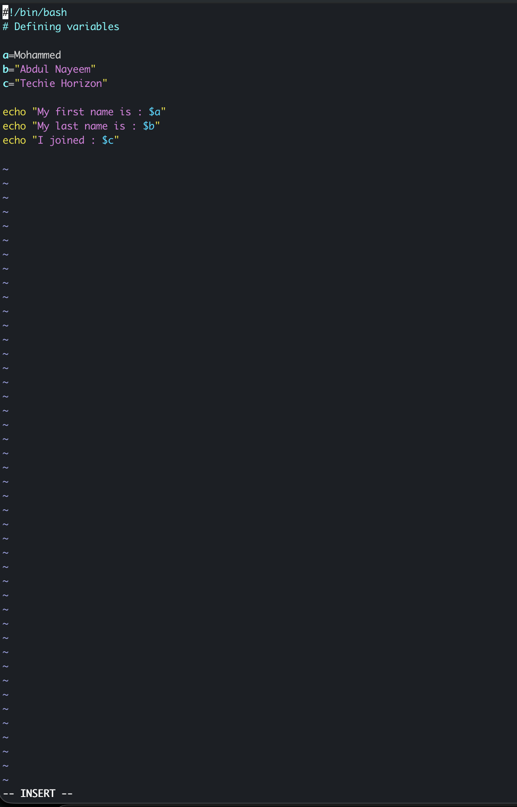

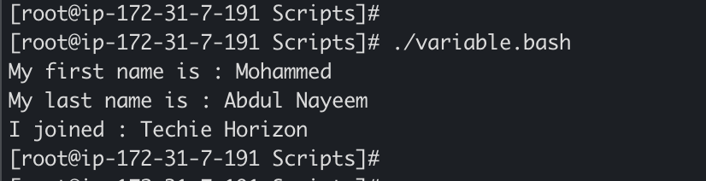

Read Input

#!/bin/bash
# Read user input

echo "What is your first name?"
read a
echo

echo "What is your last name?"
read b
echo

echo Hello $a $b
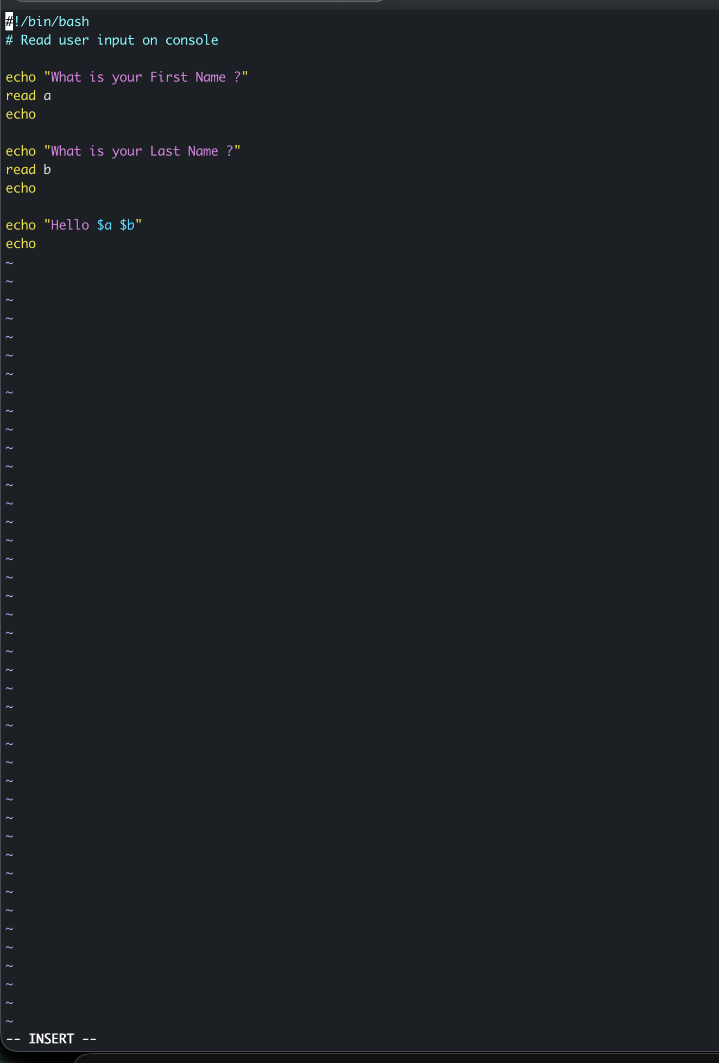

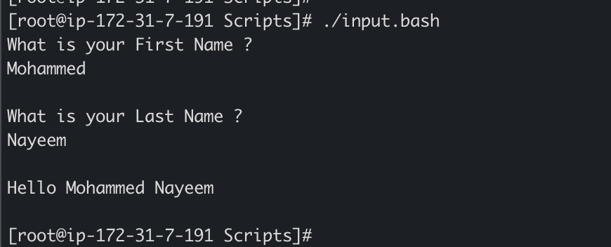

Scripts to run commands within

#!/bin/bash
# Script to run commands within

clear
echo "Hello `whoami`"
echo
echo "Today is `date`"
echo
echo "Number of user login: `who | wc -l `"
echo

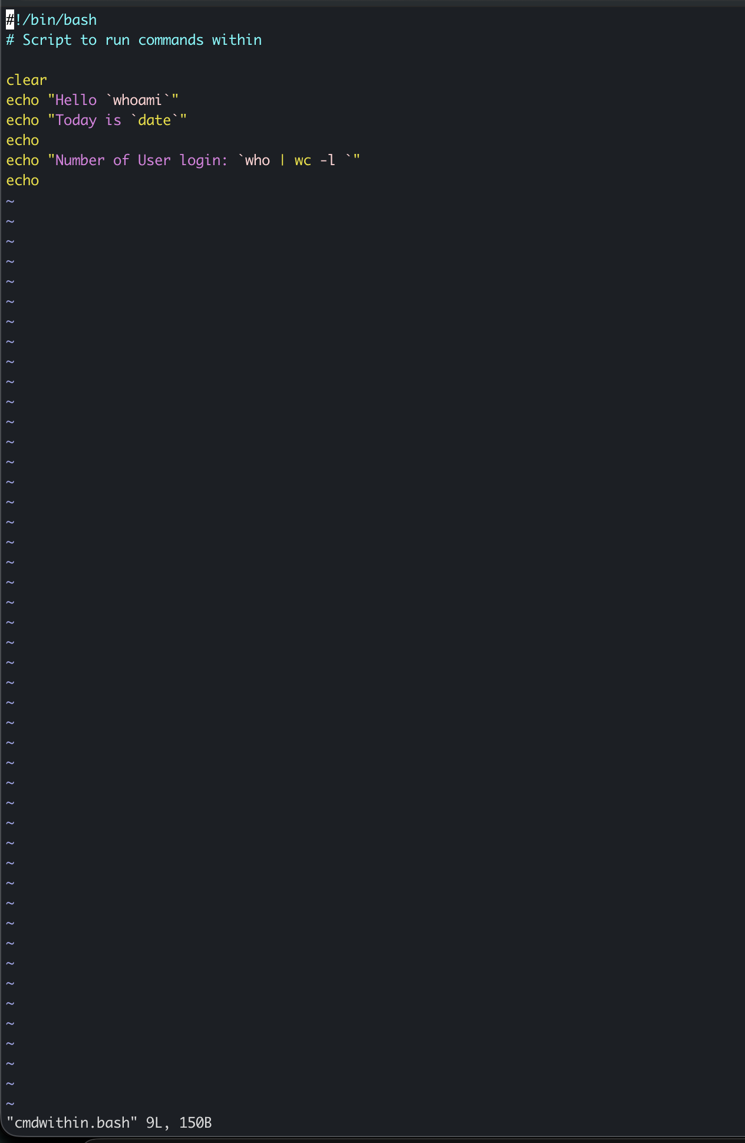

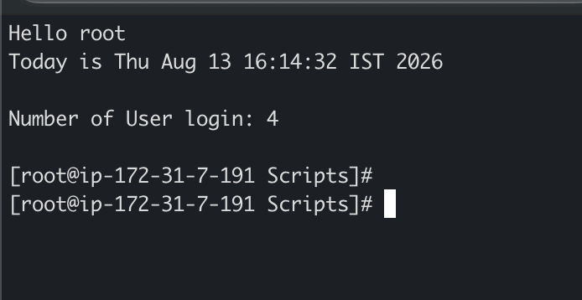

Read input and perform a task

#!/bin/bash
# Read user input and perform task

echo Enter the file name to be renamed
read oldfile

echo Enter the new file name
read newfile

mv $oldfile $newfile
echo The file name has been renamed to $newfile

